Hi Sunny –

The new gauges and the addition to the CSI chart look great. Thank you for implementing them!

There’s only one modification I’d like to make to the new gauge charts. I know that you had created custom logic to account for the full range of possible values by looking at the historical data. I appreciate you taking the time to create this. Unfortunately though, I didn’t fully appreciate how significant the outliers in the data are and consequently how much of an impact they are having on the scale.

Are we able to make some modifications to account for this?

Ideally, the Sharpe Ratio gauge will have a middle value that’s equal to the average historical value in the historical data. As of today, that value would be approximately .66 (see below)

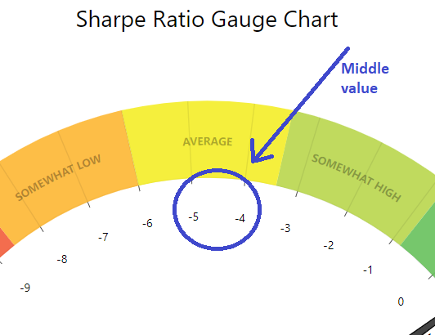

Additionally, it would be ideal if the range for this chart spanned from (-3, 3). I suppose the question becomes… how do we handle any values that are either less than -3 or greater than 3. I propose, if possible, we add “+” symbols to each of the last values on the chart’s axis. I created a mockup in Paint depicting what this could look like (please see below). This way, the chart can still communicate to the viewer that the value may be equal or possibly exceed the minimum or maximum value.

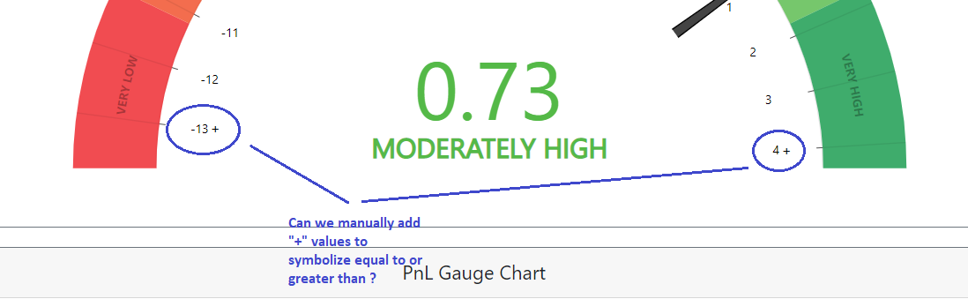

As for the chart’s ability to interpret a value outside the defined range… we could possibly create some logic that if the value exceeds the maximum as defined in the range, then the value gets changed to instead equal that maximum number so that the gauge is able to interpret the value.

As for the PnL and Volatilty gauges… ideally, the value of 0 will be the middle label and the min/max ranges would be as follows:

PnL: (-300%, 300%)

Volatility (-100%, 100%)